* https://github.com/Azure-Samples/active-directory-dotnet-desktop-msgraph-v2
* Create a user after the app creation
* 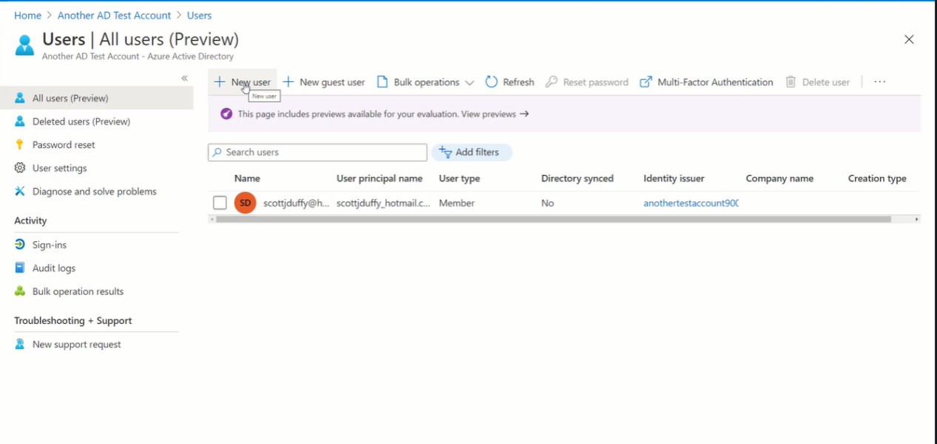
* Go into the users after the app registration.
* Email, name and password
* Usser created below
* 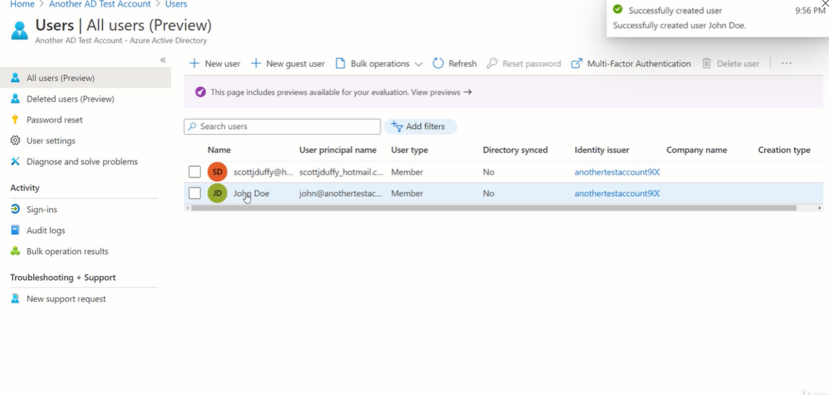
* Sign in with the user to set the password and login into the application.
* Claim the token and lifecycle is complete
* 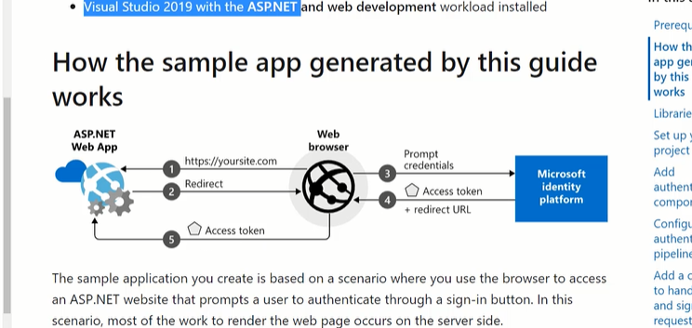
* <http://owin.org/>
* Azure AD also has multi factor authentication.
* 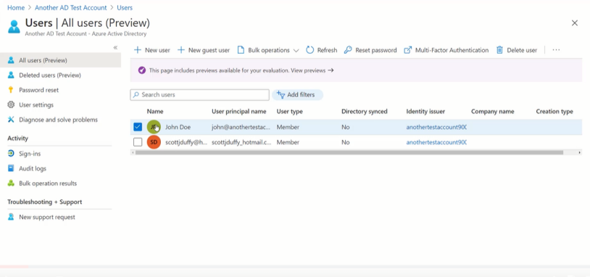
* <https://docs.microsoft.com/en-us/azure/active-directory/authentication/concept-mfa-howitworks>
* 